1. **Modeling the metabolic interplay between a parasitic worm and its bacterial endosymbiont allows the identification of novel drug targets**

<https://elifesciences.org/articles/51850>

The article "Modeling the metabolic interplay between a parasitic worm and its bacterial endosymbiont allows the identification of novel drug targets" describes a study that aimed to understand the metabolic interactions between a parasitic worm and its bacterial endosymbiont in order to identify potential drug targets.

The researchers used a combination of experimental and computational approaches to model the metabolic pathways of both the worm and the bacteria. They found that the bacteria are essential for the survival of the worm and that the two organisms have a complex metabolic interplay that involves the exchange of nutrients and metabolites.

Using the model, the researchers identified several potential drug targets that could disrupt the metabolic interactions between the worm and the bacteria, thereby leading to the death of the worm.

The importance of this research lies in the fact that parasitic worms cause a significant burden of disease in many parts of the world, particularly in developing countries. Current treatments for these infections are often inadequate and can have side effects. Identifying new drug targets based on a deeper understanding of the metabolic interactions between the worm and its bacterial endosymbiont could lead to the development of more effective and safer treatments for these infections.

>> bacteria와 worm은 서로 nutrient와 metabolite를 공유(endosymbiotic)

>> metabolic interaction을 방해할 수 있는 drug target을 찾으려고 computer model로 구현

>> metabolic interaction의 깊은 이해를 통해 효과적인 치료제를 만들 수 있음

1. **Evolution of C4 photosynthesis predicted by constraint-based modeling**

<https://elifesciences.org/articles/49305#data>

The article "Evolution of C4 photosynthesis predicted by constraint-based modeling" discusses a study that used computational models to investigate the evolution of C4 photosynthesis, a photosynthetic pathway used by certain plants that allows for more efficient carbon fixation in hot and dry environments.

The researchers developed a model that predicts the optimal evolutionary trajectory for the development of C4 photosynthesis in plants. They found that the evolution of C4 photosynthesis is constrained by several factors, including the availability of carbon dioxide and the energetic cost of building and maintaining the necessary anatomical and biochemical structures.

Using this model, the researchers were able to identify specific genetic changes that could enable the evolution of C4 photosynthesis in certain plant lineages. They also found that the evolution of C4 photosynthesis is more likely to occur in certain environmental conditions, such as in hot and dry regions.

The importance of this research lies in its potential implications for agriculture and climate change. C4 plants, which include many important crops such as maize and sugarcane, are more efficient at using water and nitrogen than C3 plants, and therefore have the potential to be more resilient to drought and other environmental stresses. Understanding the evolutionary constraints and potential genetic pathways for the development of C4 photosynthesis could lead to the development of crops that are better adapted to changing climate conditions and can sustainably meet the increasing demands for food and bioenergy.

>> 대부분의 식물들이 C3 pathway를 사용, 하지만 C4를 사용하는 식물도 있음

>> C4: more hot & dry condition에서도 잘자람

>> C4: water and nitrogen 사용이 C3보다 더 효율적임

>> genetic pathways를 이용해 C4로 발전시킬 수 있음

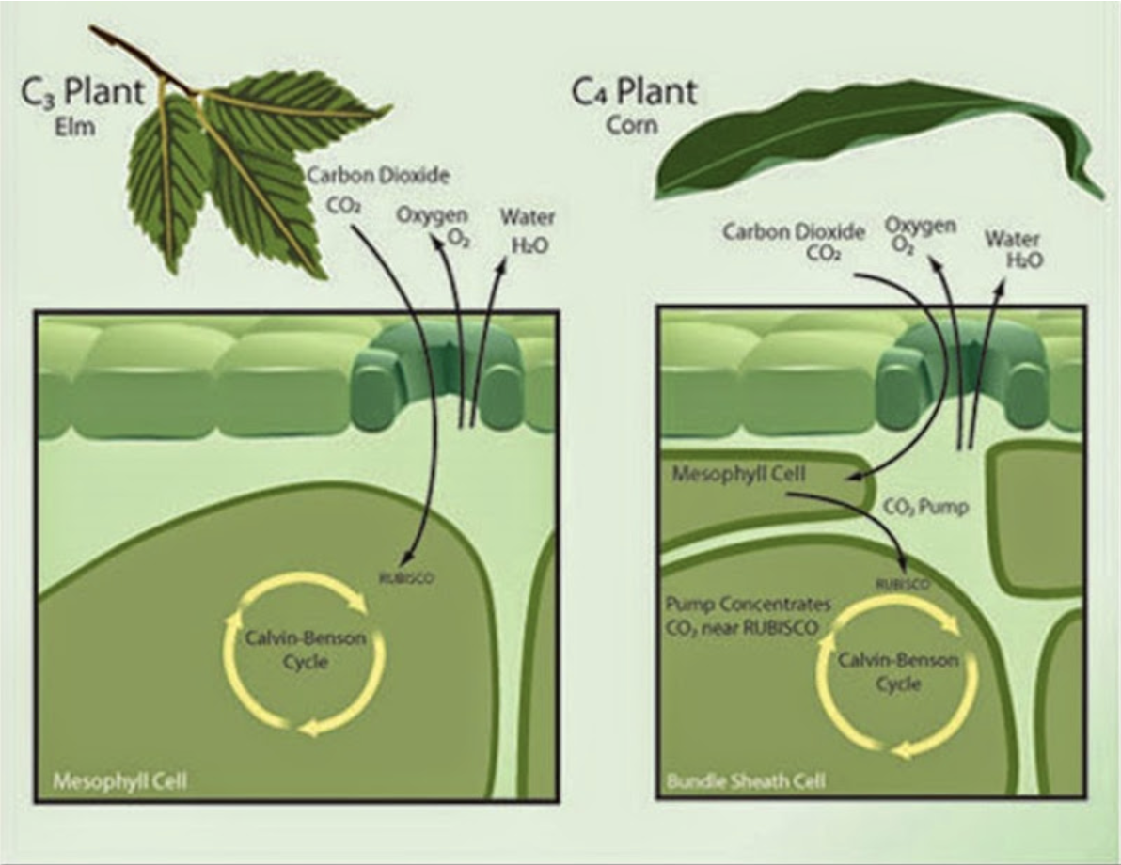

1. **Mitochondrial dysfunction remodels one-carbon metabolism in human cells**

<https://elifesciences.org/articles/10575>

The article "Mitochondrial Dysfunction Remodels One-Carbon Metabolism in Human Cells" explores how dysfunctional mitochondria, the energy-producing structures within cells, can impact one-carbon metabolism in human cells. One-carbon metabolism is a complex network of biochemical reactions that play a crucial role in cellular processes such as DNA synthesis, amino acid metabolism, and cellular redox balance.

The researchers conducted experiments on human cells with dysfunctional mitochondria and found that it led to significant changes in one-carbon metabolism. Specifically, they observed alterations in the levels of key metabolites involved in one-carbon metabolism, such as serine, glycine, and formate. These changes were attributed to impaired mitochondrial function, which disrupted the balance of cellular energy production and redox status.

The importance of this research lies in its implications for understanding the interplay between mitochondrial function and cellular metabolism. Dysfunctional mitochondria are known to be associated with a variety of human diseases, including metabolic disorders, neurodegenerative diseases, and cancer. By uncovering how mitochondrial dysfunction can remodel one-carbon metabolism, this research sheds light on the underlying molecular mechanisms that link mitochondrial dysfunction to cellular metabolic changes.

Furthermore, one-carbon metabolism is a critical pathway for providing cells with the necessary building blocks for growth and proliferation. The findings from this study contribute to our understanding of how mitochondrial dysfunction can disrupt cellular metabolism and potentially impact cellular health and disease outcomes. It also highlights the intricate relationship between mitochondria and cellular metabolism, and how disruptions in this relationship can have wide-ranging effects on cellular physiology. This research may have implications for the development of novel therapeutic strategies targeting mitochondrial dysfunction-associated diseases by modulating one-carbon metabolism.

>> 이 논문은 인간 세포에서 mitochondrial dysfunction이 다양한 병리학적 현상을 유발하는 방법을 이해하는 문제에 대해 다루고 있음

>> mitochondrial dysfunction은 대사의 유전적인 오류로부터 노화와 같은 일반적인 나이 관련 질환에 이르기까지 다양한 인간 질환과 관련되어 있음

>> mammalian cells에서 대한 mitochondrial dysfunction은 아직 잘 연구가 되지 않음

>> 이 연구를 통해 mitochondrial respiratory chain dysfunction이 one-carbon metabolism pathways에 변화를 일으킨다는 것을 알아냄. 이러한 질환의 기저 메커니즘을 밝혀주고 이 분야의 미래 연구를 위한 기초를 마련하였다.

# **Constraint-Based Modeling of Carbon Fixation and the Energetics of Electron Transfer in *Geobacter metallireducens***

[**https://doi.org/10.1371/journal.pcbi.1003575**](https://doi.org/10.1371/journal.pcbi.1003575)

The article "Constraint-Based Modeling of Carbon Fixation and the Energetics of Electron Transfer in *Geobacter metallireducens*" presents a computational model that simulates the metabolism of *Geobacter metallireducens*, a bacterium that can use metals as electron acceptors to generate energy. The model uses constraint-based modeling techniques to predict the metabolic capabilities of *G. metallireducens* under different environmental conditions.

The authors found that *G. metallireducens* can use several alternative pathways to fix carbon, which allows it to adapt to different carbon sources and availability. They also investigated the energetics of electron transfer in *G. metallireducens* and found that the bacterium can use different mechanisms to transfer electrons to metal ions, depending on the availability of electron donors and acceptors.

The importance of this article lies in the fact that it provides insights into the metabolic capabilities and energy generation mechanisms of *G. metallireducens*, which could have potential applications in bioremediation, biotechnology, and microbial ecology. The computational model presented in the article can be used to design experiments to test the predictions of the model and to explore the metabolism of other microorganisms.

>>금속을 electron acceptors로 사용하여 *Geobacter metallireducens* 의 대사기능을 예측

>>탄소 고정을 위한 대체 경로를 이용하였고, 전자를 금속 이온으로 전달하기 위해 사용할 메커니즘을 발견하였음

>>*G. metallireducens* 는 대사 경로와 에너지 생성 메커니즘에 대한 통찰력을 제공

>>미생물의 탄소 고정과 전자 전달의 복잡한 상호작용에 대해 넓은 분야에서 영향을 줌

1. **Modeling Power Generation and Energy Efficiencies in Air-Cathode Microbial Fuel Cells Based on Freter Equations**

<https://www.mdpi.com/2076-3417/8/10/1983>

The article "Modeling Power Generation and Energy Efficiencies in Air-Cathode Microbial Fuel Cells Based on Freter Equations" focuses on the use of microbial fuel cells (MFCs) for power generation and energy efficiency. The authors utilize mathematical modeling based on Freter equations to describe the performance of MFCs in terms of power output and energy efficiency.

The article discusses the key components of MFCs, including the air-cathode, anode, and cathode, and their roles in the microbial processes that generate electricity. The authors then propose a mathematical model based on Freter equations to describe the complex bio-electrochemical reactions occurring in MFCs.

The importance of this research lies in the potential of MFCs as a sustainable energy technology. MFCs offer a unique approach to generate electricity by utilizing microorganisms to convert organic matter into electrical energy. Understanding the performance of MFCs through mathematical modeling, as proposed in this article, can aid in optimizing MFC design and operation, and help improve power generation and energy efficiency. This research can contribute to the development of more efficient and sustainable microbial fuel cells for renewable energy production, wastewater treatment, and other environmental applications.

>> 이 논문은 Freter equation을 제안하며 다른 operating conditions에서 power generation and energy efficiencies in air-cathode microbial fuel cells 예측할 수 있다고 제안함.

>> 이 논문에서 다양한 operating variables에서 initial substrate concentration, external resistor, influent substrate concentration, and dilution rate등이 microbial fuel cells 성능에 미치는 영향을 조사하였음.

>> 이 논문에서 제안한 모델은 연구자와 엔지니어에게 microbial fuel cells의 효율적인 electricity generation와 organic substrate removal에 도움을 줄 수 있다고 함